R7Lite PCIE Demo Introduction

ISE Project
Top module showed as figure 1.
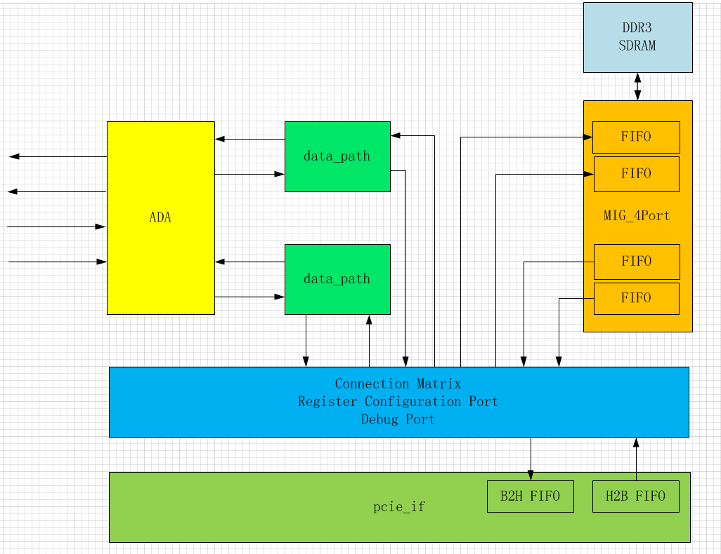
Figure 1

HDL module
The top module showed as Figure1 consists of the following modules,
- ADA: AD and DA interface;
- Data_path: sequence and cach the data;
- MIG_4Port : 4 ports MIG controller(dual input and dual output);
- Connection Matrix: datapath of pcie to/from ddr3 memory, and pcie user regs;
- pcie_if: pcie interface and fifo interface;

PCIE Data Flow

Datapath Module(Verilog)
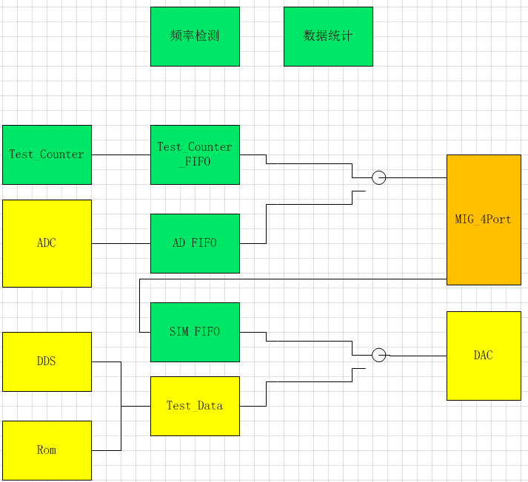

Connection Module(Verilog)
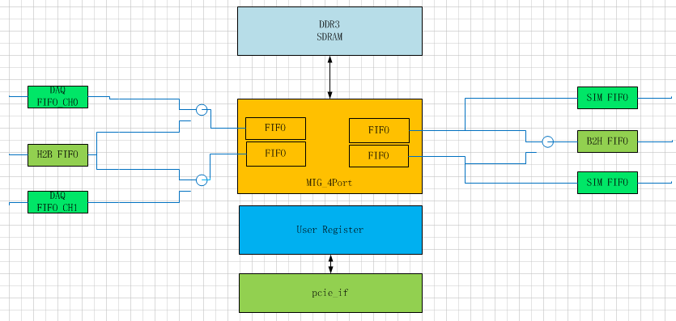
PCIE regs read/write implemented in this module;

MIG_4Port(Verilog)
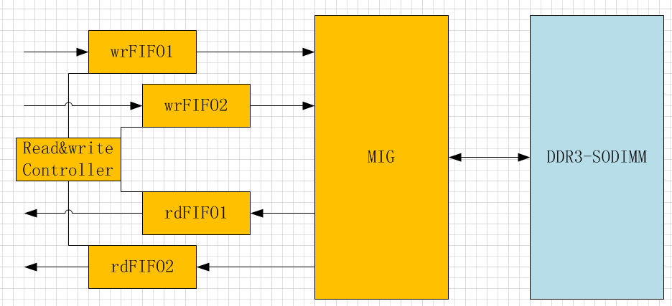
Read/Write Priority：wrFIFO1 > wrFIFO2 > rdFIFO1 > rdFIFO2;

pcie_if Module (Verilog)
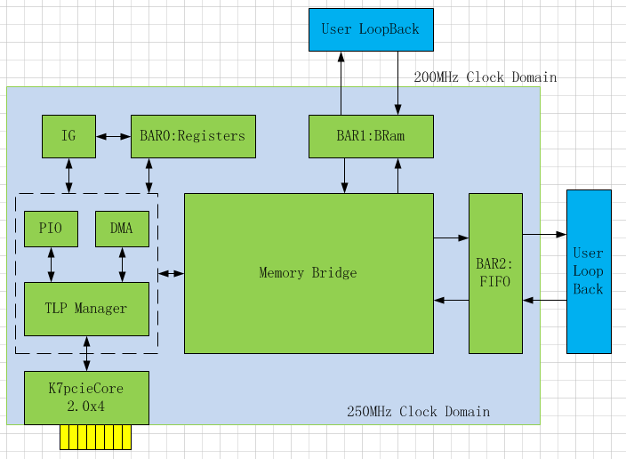
Only BAR0 used in this demo;

DMA/PIO Engine(VHDL)
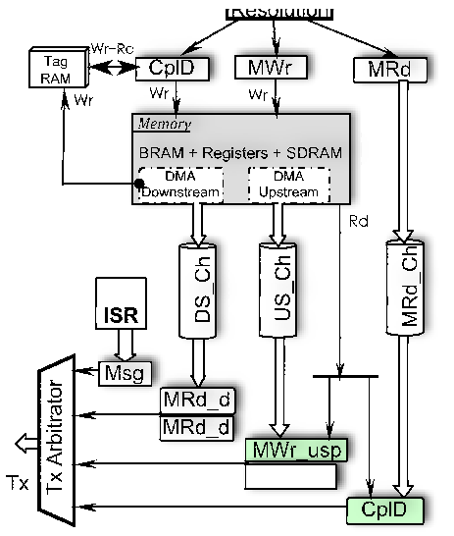

Registers List
Num | Name | Offset | R/W | BAR
 | System section
0 | Design ID Register (DID) | 0x0000 | RO | 0
2 | Interrupt Status Register (ISR) | 0x0008 | RO | 0
4 | Interrupt Enable Register (IER) | 0x0010 | R + W | 0
6 | General Error Register (GER) | 0x0018 | RO | 0
8 | General Status Register (GSR) | 0x0020 | RO | 0
10 | General Control Register (GCR) | 0x0028 | R + W | 0
 | Upstream DMA channel（B2H）
11 | Peripheral Address high-DW | 0x002C | R + W | 0
12 | Peripheral Address low-DW | 0x0030 | R + W | 0
13 | Host address high-DW | 0x0034 | R + W | 0
14 | Host address low-DW | 0x0038 | R + W | 0
15 | Next Buffer Descriptor Address high-DW | 0x003C | R + W | 0
16 | Next Buffer Descriptor Address low-DW | 0x0040 | R + W | 0
17 | Length in bytes | 0x0044 | R + W | 0
18 | Control | 0x0048 | R + W | 0
19 | Status | 0x004C | RO | 0
 | Downstream DMA channel（H2B）
20 | Peripheral Address high-DW | 0x0050 | R + W | 0
21 | Peripheral Address low-DW | 0x0054 | R + W | 0
22 | Host address high-DW | 0x0058 | R + W | 0
23 | Host address low-DW | 0x005C | R + W | 0
24 | Next Buffer Descriptor Address high-DW | 0x0060 | R + W | 0
25 | Next Buffer Descriptor Address low-DW | 0x0064 | R + W | 0
26 | Length in bytes | 0x0068 | R + W | 0
27 | Control | 0x006C | R + W | 0
28 | Status | 0x0070 | RO | 0
 | PIO Path Controls
29 | MRd channel control | 0x0074 | WO | 0
30 | CplD channel control | 0x0078 | WO | 0
 | ICAP(reserved)
31 | ICAP port write | 0x007C | W | 0
31 | ICAP port read | 0x007C | R | 0
 | Interrupt Generation
32 | Interrupt Generation Control (IGC) | 0x0080 | R + W | 0
33 | Interrupt Generation Latency (IGL) | 0x0084 | R + W | 0
34 | Interrupt Generation On Statistic (IGN_ON) | 0x0088 | RO | 0
35 | Interrupt Generation Off Statistic (IGN_OFF) | 0x008C | RO | 0
 | FIFO Control and Status
36 | Control | 0x0090 | W | 0
36 | Status | 0x0090 | R | 0
 | DMA Actual Transferred
37 | Upstream transferred byte count | 0x0094 | RO | 0
38 | Downstream transferred byte count | 0x0098 | RO | 0
39 | DCB protocol link status (R) + control (W) | 0x009C
40 | CTL class register | 0x00A0 | R + W | 0
41 | DLM class register | 0x00A4 | R + W | 0
42 | Data generator control register | 0x00A8 | W | 0
43 | Traffic classes status | 0x00AC | R | 0
44~53 | USER REGISTER 01~10 | 0x00B0~0x00D4 | R + W | 0
54 | Host2Board FIFO status | 0x00D8 | R | 0
55 | Board2Host FIFO status | 0x00DC | R | 0
56~59 | USER REGISTER 11~14 | 0x00E0~0x00EC | R + W | 0
60~65 | USER REGISTER 15~20 | 0x00F0~0x0104 | R + W | 0
66~69 | USER REGISTER 21~25 | 0x0108~0x0118 | R + W | 0
 | TxFIFO write port | 0x4010
 | TxFIFO Reset | 0x4018 | W
 | TxFIFO Vacancy status | 0x4018 | R
 | RxFIFO read port | 0x4020
 | RxFIFO Reset | 0x4028 | W
 | RxFIFO Occupancy status | 0x4028 | R
 | Large memory (1 MB)
 | Block RAM (32 KB) | 0x8000~0xBFFF | R + W | 1
 | Other regions reserved 1 |  |  | 1
 | Event FIFO Data Interface
 | Read | 0x0000 | R | 2
 | Write | 0x0000 | W | 2

- Interrupt Status Register (ISR)
31:29 | 28 | 27 | 26 | 25 | 24 | 23 | 22 | 21 | 20 | 19 | 18 | 17 | 16
 | 2CH  Timeout | Ch1  Timeout | Ch0  Timeout |  | 2CH | Ch1  DAQ | Ch0  DAQ | dsDMA Timeout | usDMA Timeout |  | IG | dsDMA Done | usDMA Done

15:6 | 5 | 4 | 3 | 2 | 1 | 0
 | dsDMA Timeout | usDMA Timeout |  | IG | dsDMA Done | usDMA Done

- Interrupt Enable Register (IER)
The higher 16bits are used only for keeping status not generate interrupt;
The lower 16bits are used for generating interrupt and cleared automatically;

31:29 | 28 | 27 | 26 | 25 | 24 | 23 | 22 | 21 | 20 | 19 | 18 | 17 | 16
 | 2CH  Timeout | Ch1  Timeout | Ch0  Timeout |  | 2CH | Ch1  DAQ | Ch0  DAQ | dsDMA Timeout | usDMA Timeout |  | IG | dsDMA Done | usDMA Done

15:6 | 5 | 4 | 3 | 2 | 1 | 0
 | dsDMA Timeout | usDMA Timeout |  | IG | dsDMA Done | usDMA Done

- User Register
Num | Description（32bits） | BAR0 Offset(+0x00B0)
44 | Channel 0 Ctrl | 0x00B0
44 | Channel 0 Status | 0x00B0
45 | Channel 0 performance, high 32bit | 0x00B4
46 | Channel 0 performance, low 32bit | 0x00B8
47 | reserve | 0x00BC
48 | reserve | 0x00C0
49 | reserve | 0x00C4
50 | reserve | 0x00C8
51 | Channel 0 total amount of data, high 32bit | 0x00CC
52 | Channel 0 total amount of data, low 32bit | 0x00D0
53 | Channel 0 total amount of data cached in DDR3 | 0x00D4
 | Host2Board FIFO status | 0x00D8
 | Board2Host FIFO status | 0x00DC
56 | Channel 1 Ctrl | 0x00E0
56 | Channel 1 Status | 0x00E0
57 | Channel 1 performance, high 32bit | 0x00E4
58 | Channel 1 performance, low 32bit | 0x00E8
59 | reserve | 0x00EC
60 | reserve | 0x00F0
61 | reserve | 0x00F4
62 | reserve | 0x00F8
63 | Channel 1 total amount of data, high 32bit | 0x00FC
64 | Channel 1 total amount of data, low 32bit | 0x00100
65 | Channel 1 total amount of data cached in DDR3 | 0x00104
66 | Channel 0 DMA bulk size | 0x00108
67 | Channel 1 DMA bulk size | 0x0010C
68 | reserve
69 | reserve
70 | reserve

- DMA Descriptor
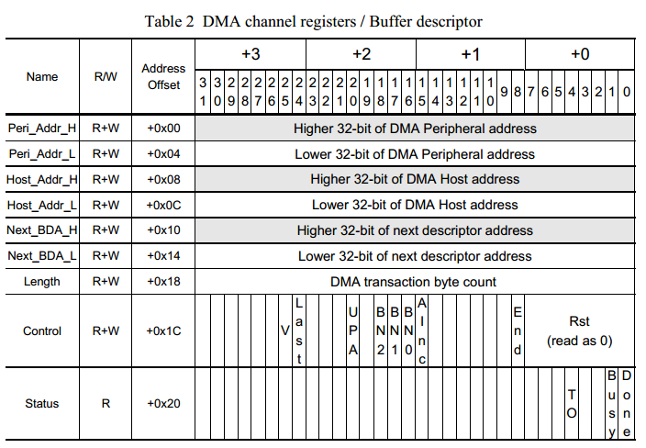
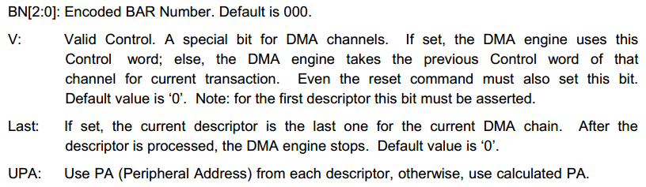
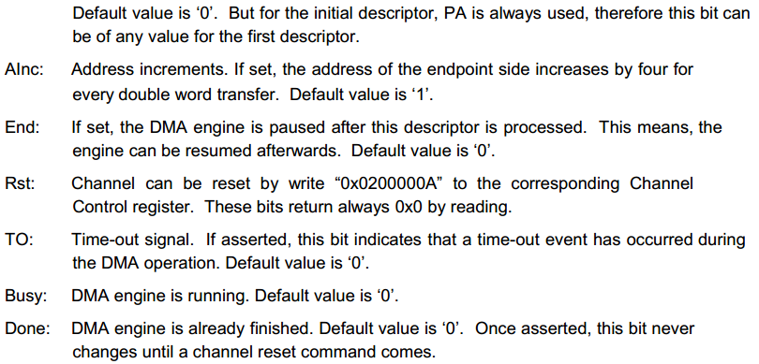
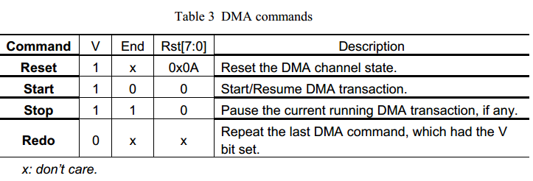
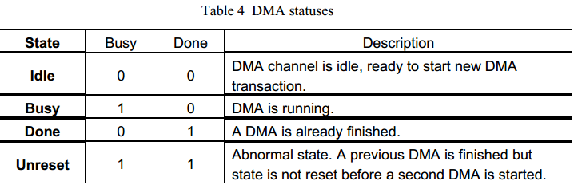

Software Test in Linux

Install Driver
- 1>. Unzip driversetup.7z
- 2>. # su root
- 3>. # ./driver_setup
- 4>. Reboot PC
If you got the following messages, just ignore them.
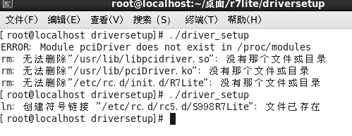

Driver Source
- All driver source code are in the driver.7z package;
- About driver API introduction please refer to driver/doc/manual.html;

Demo App Source
- All demo app source code are in the driver/src/r7lite;

- Testing the demo by the flowing steps.
1>. Open the console window and run the app;
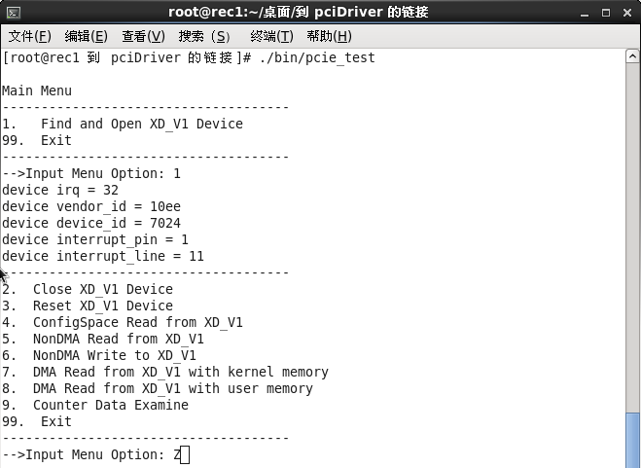

2>. Input the number to choose the testing option;
To choose 8 to test DMA;
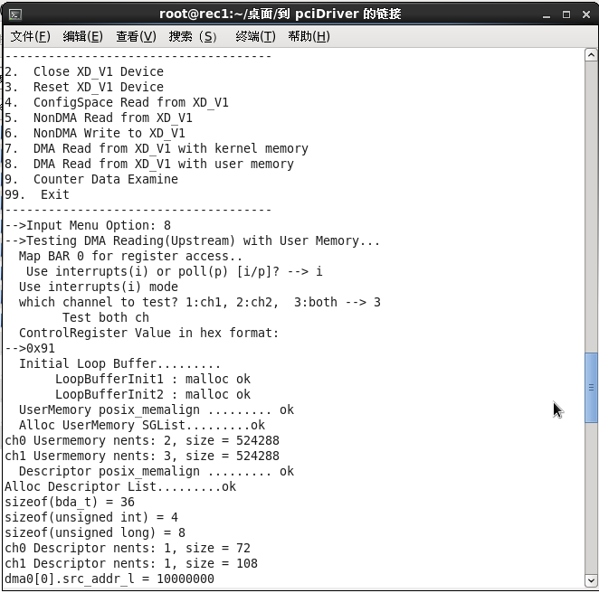
3>. The DMA process in loop;
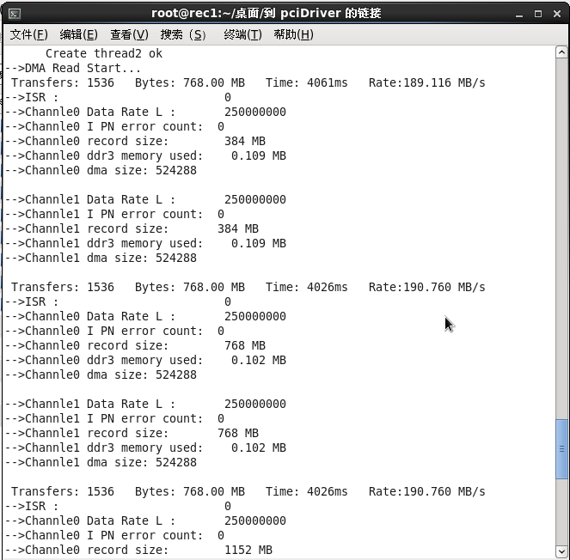
4>. Use ESE to quit;
